Calamity Cooking
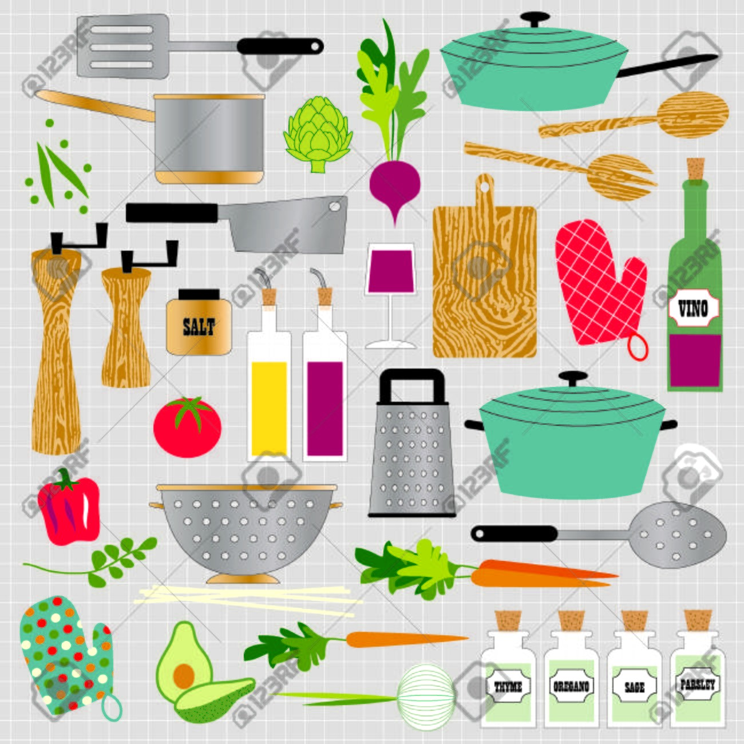

PASTA INFORMATION

This list of pastas is just a start and does not include all pastas in use in culinary kitchens all around the world. The easiest to get your hands on here in the U.S. Are highlighted in bold lettering. This will just help you identify the pasta from a rcipe and what to look for when searching for a pasta. Remember, some is must be handmade or purchased frozen such as Ravioli's or Tortellini's which are already stuffed. Bon Apetit!
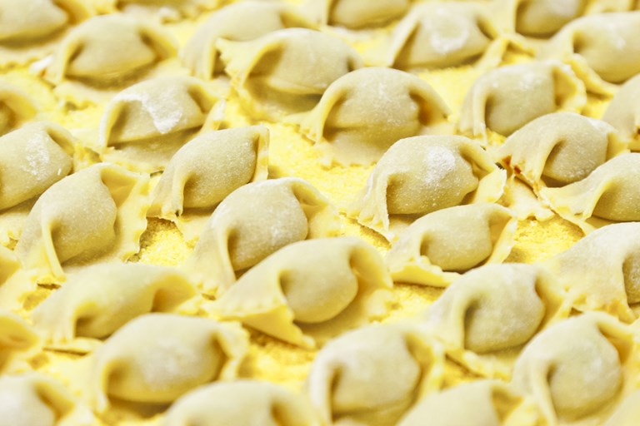
Agnolotti – Semi circle stuffed pasta with ruffled edges. handmade

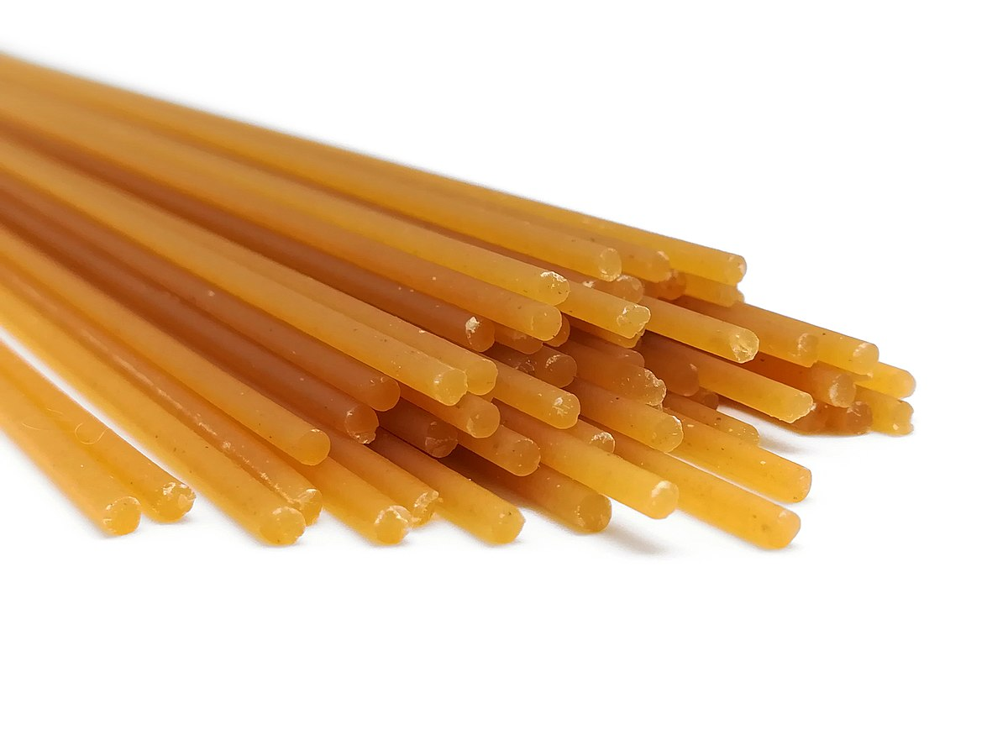
Bigoli – Rough looking thick spaghetti made from buckwheat

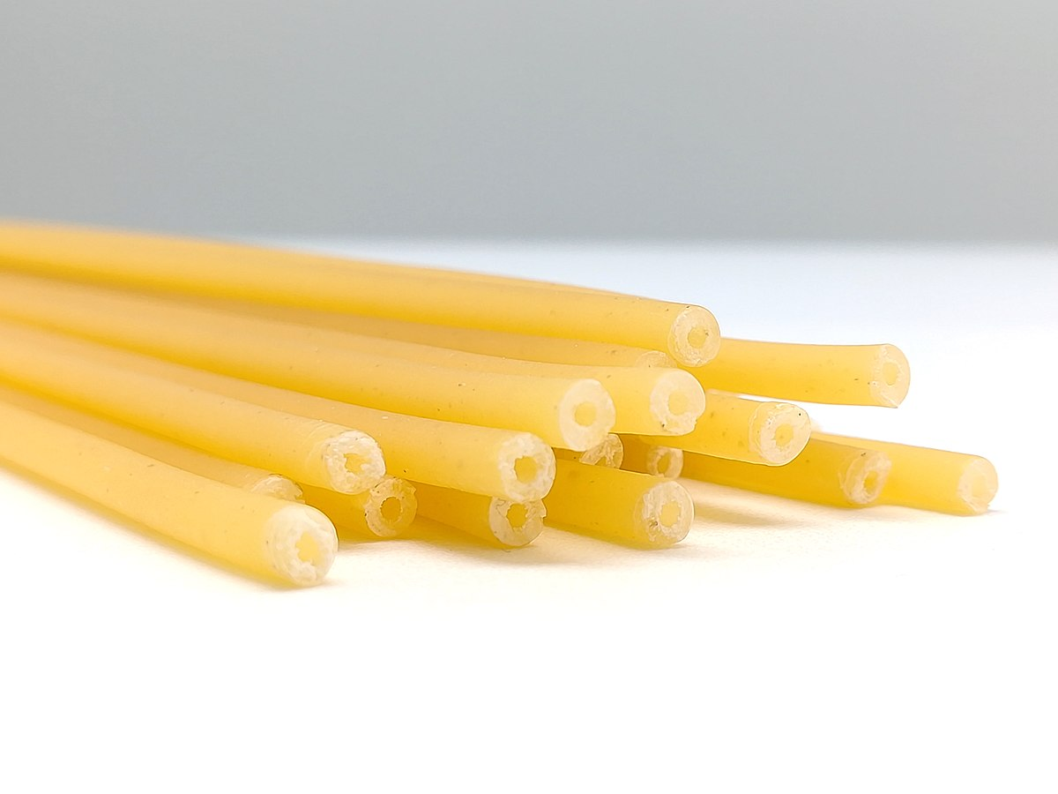

Bucatini – Thicker than spaghetti with a hole through the middle like a hollow
tube.
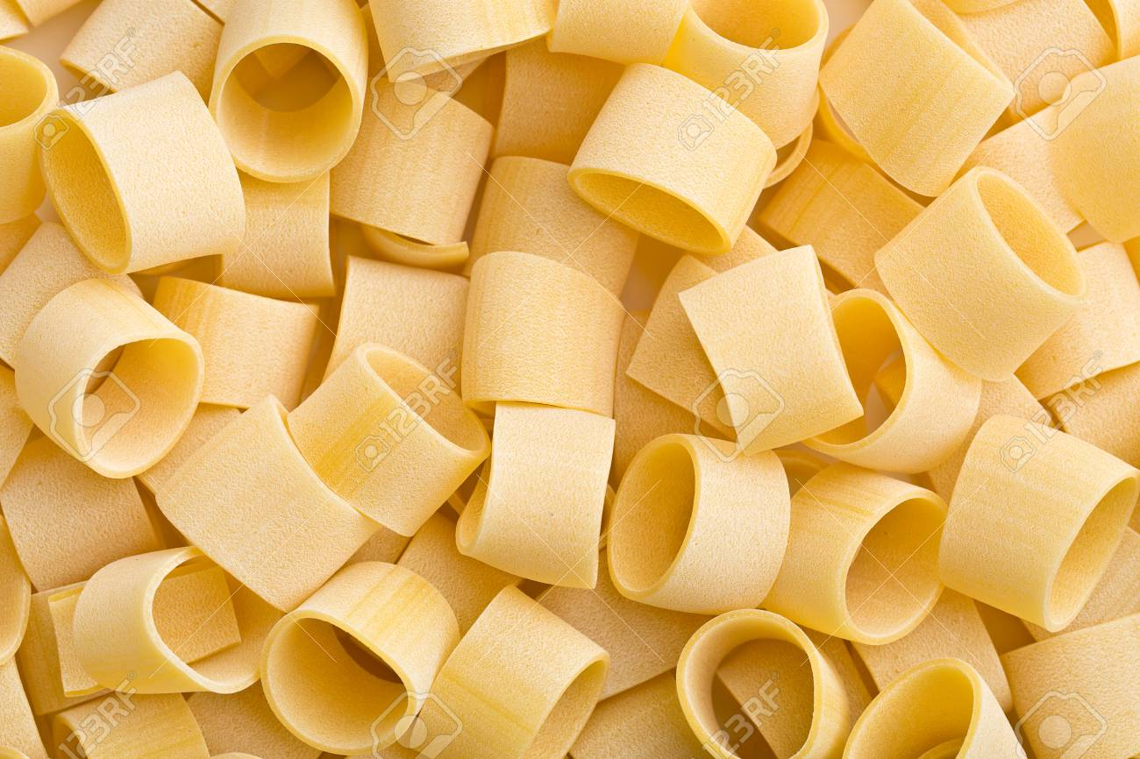
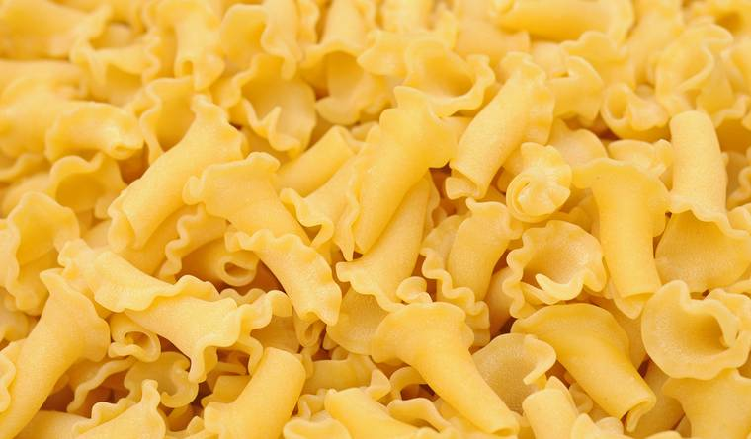
Calamarata – Wide ring shaped pasta similar to Ditalini but larger

Campanelle – Frilly edged, bell shaped. Twisted egg noodle

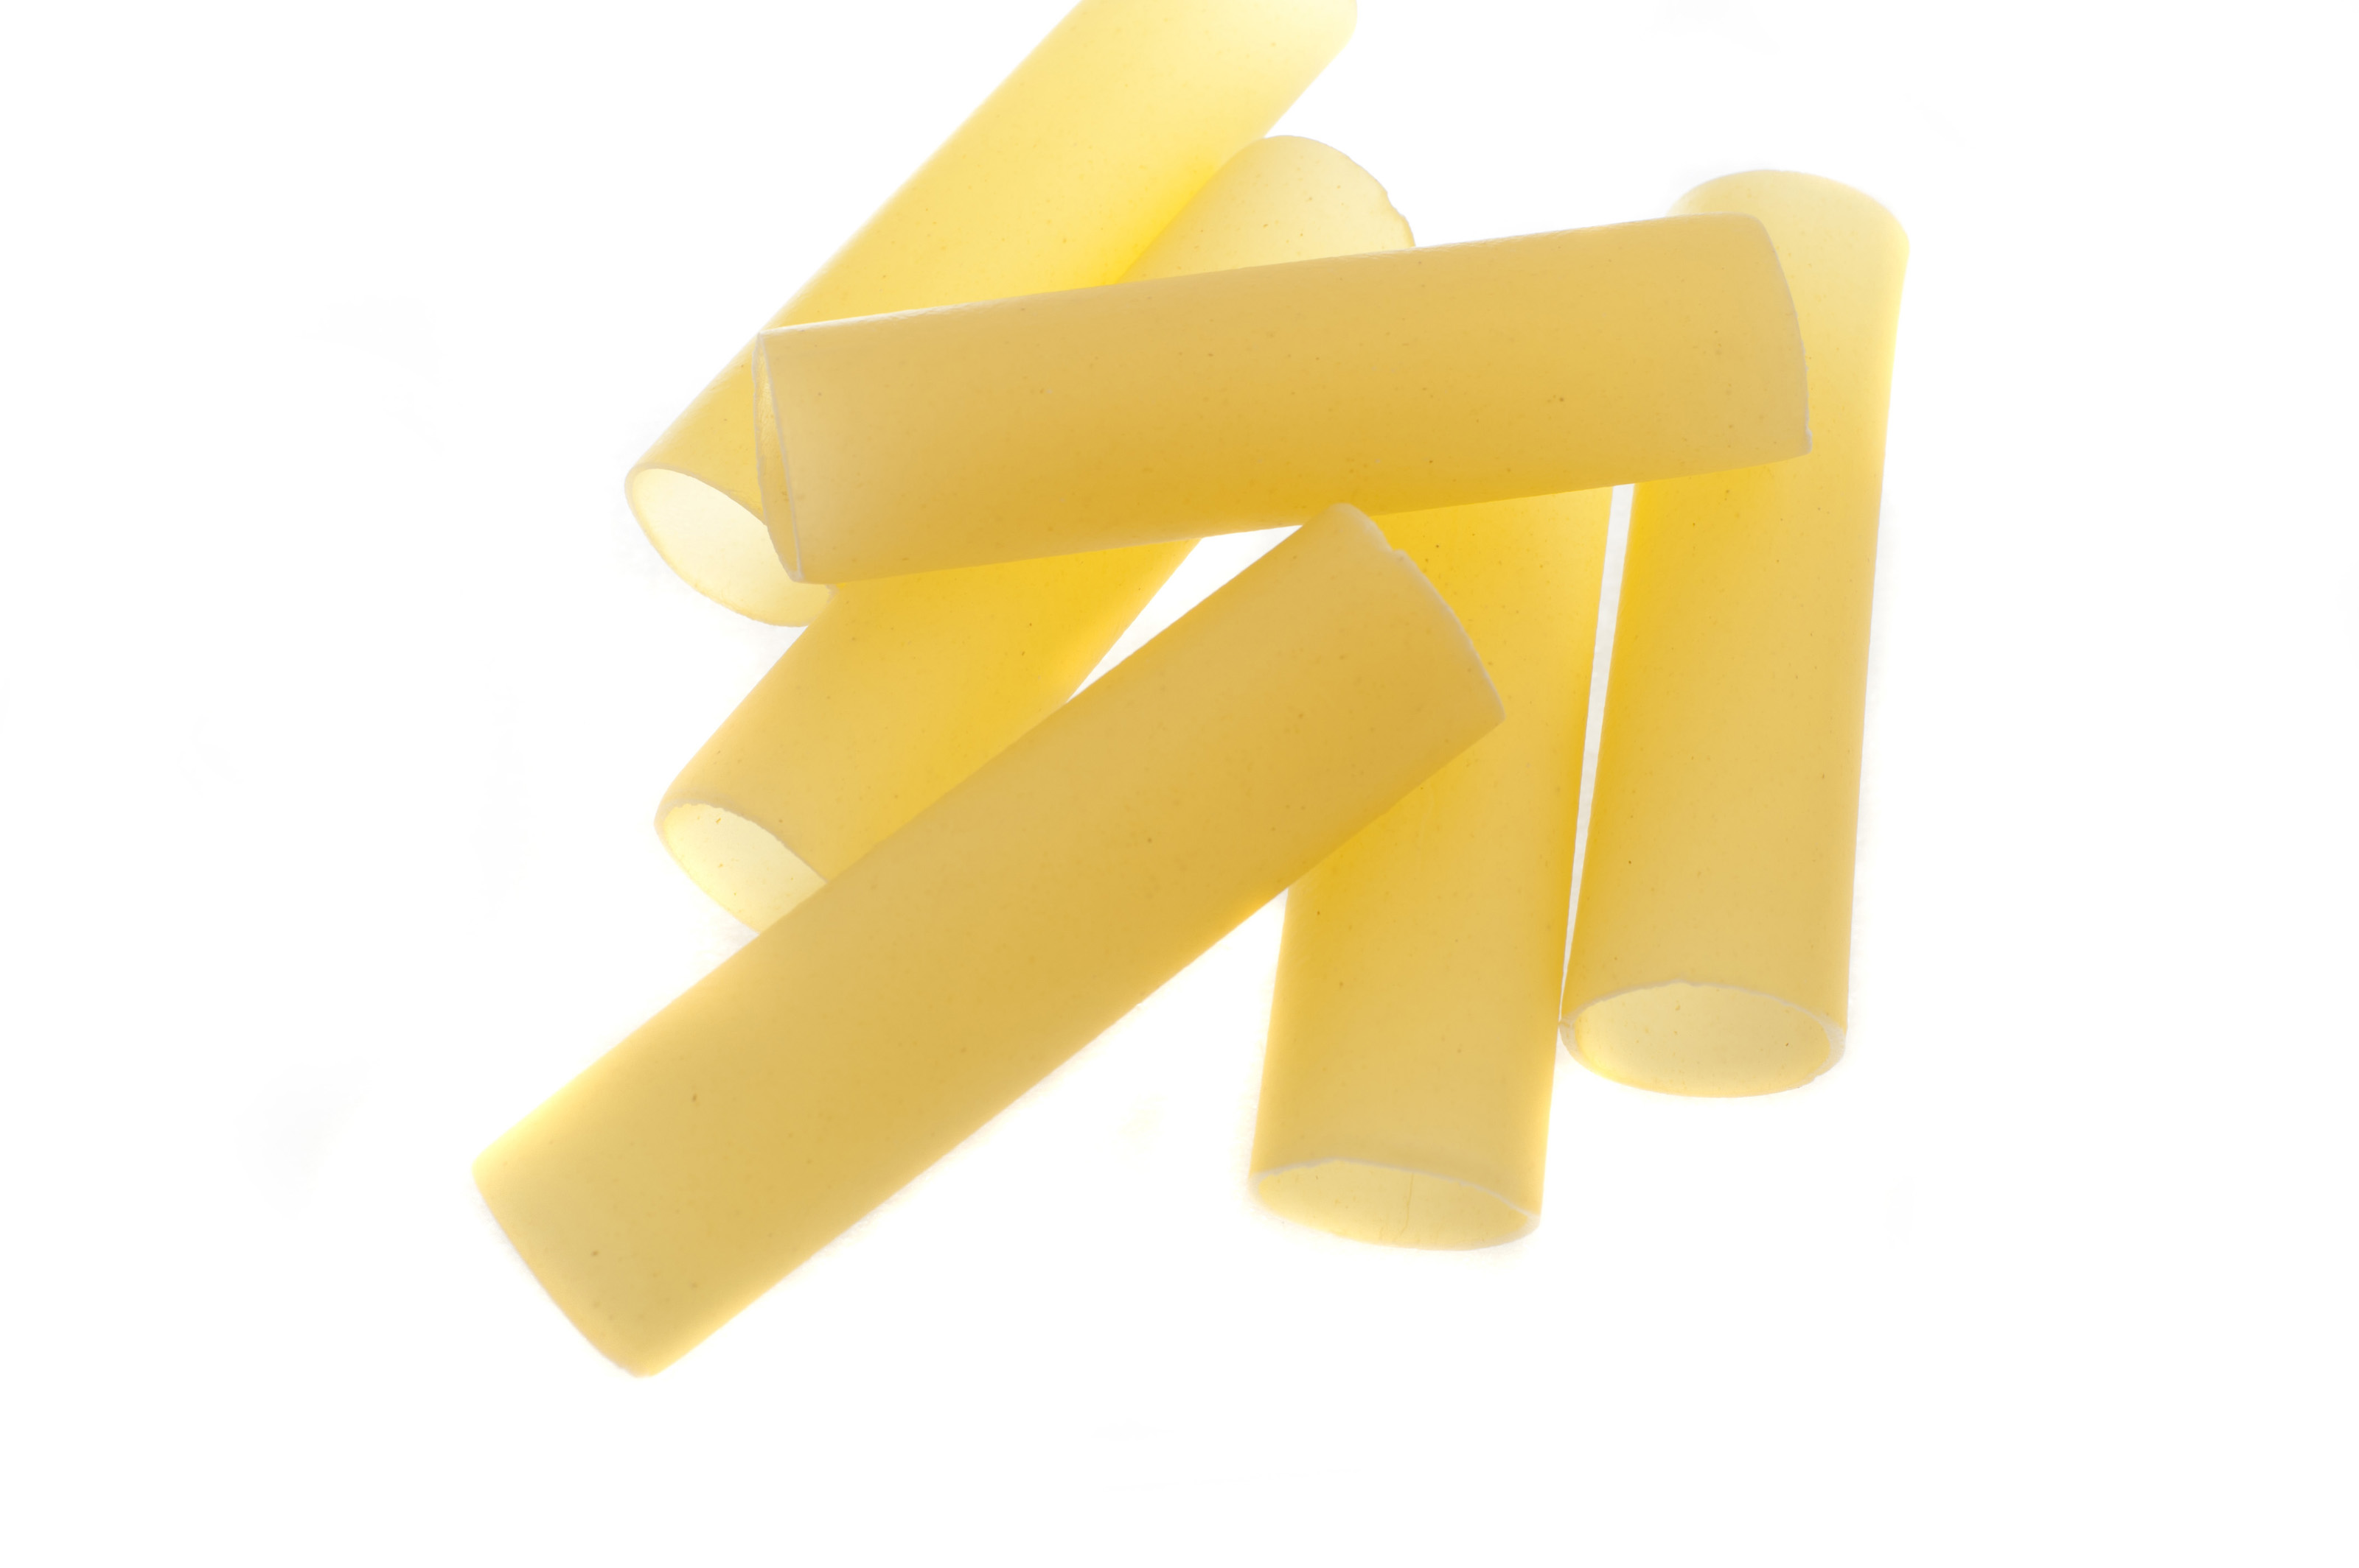

Canneloni – 1”x4” pasta tubes used for filling, Manicotti in U.S.

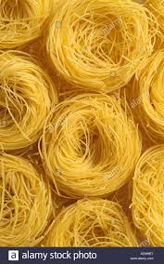

Capellini – Extremely thin spaghetti pasta, very fine sold in nests

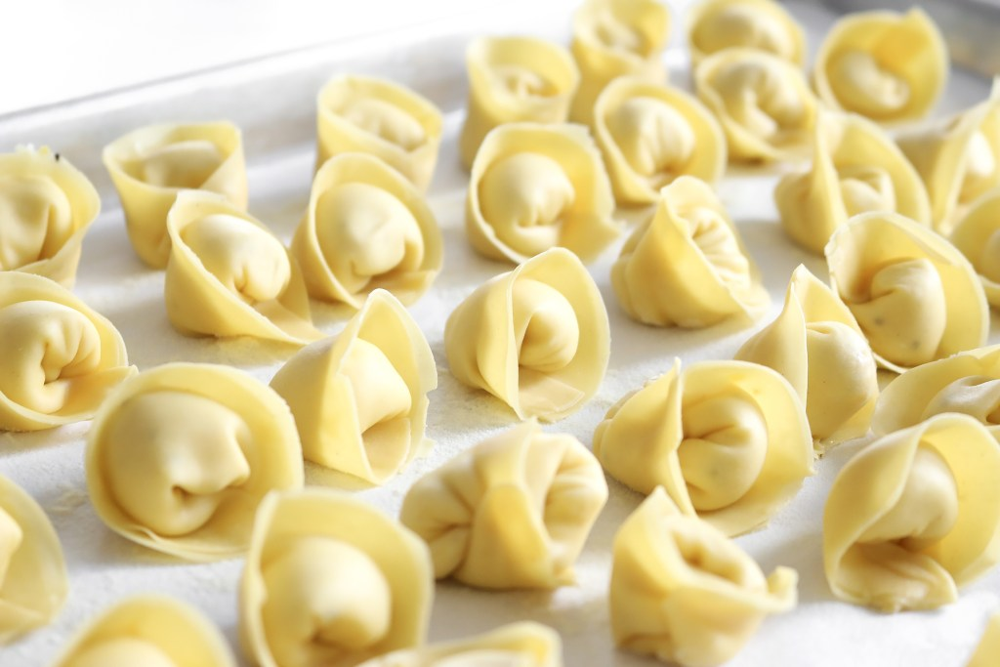

Capalleti – Stuffed pasta looks like tortellini but usually stuffed with cheeses,
handmade or in frozen department

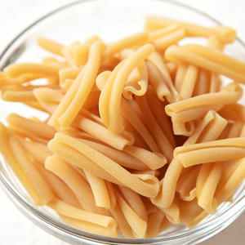

Casarecce – 2” long rolled, twisted pasta, looks like a double strands together

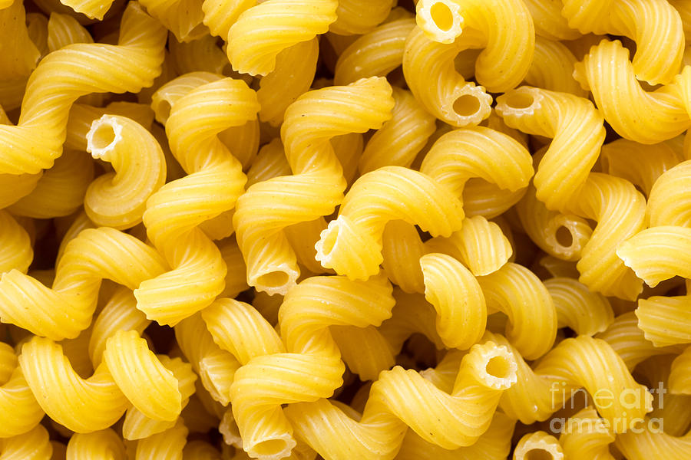

Cavatappi – Corkscrew shaped macaroni with ridges

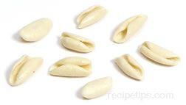

Cavatelli – Short mini hot dog bun looking pasta

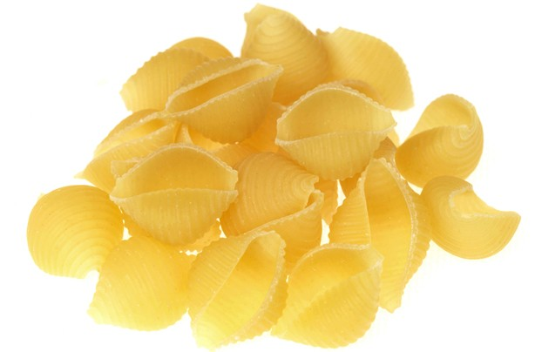

Conchiglie – Seashell shaped pasta. Shells in U.S.

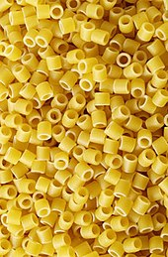

Ditalini -Small short tube, ring shape pasta

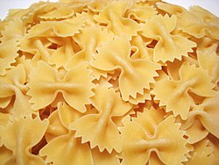

Farfalle – Butterfly or bow tie shaped pasta

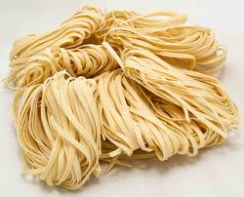

Fettucini – Thick flat ribbons of pasta

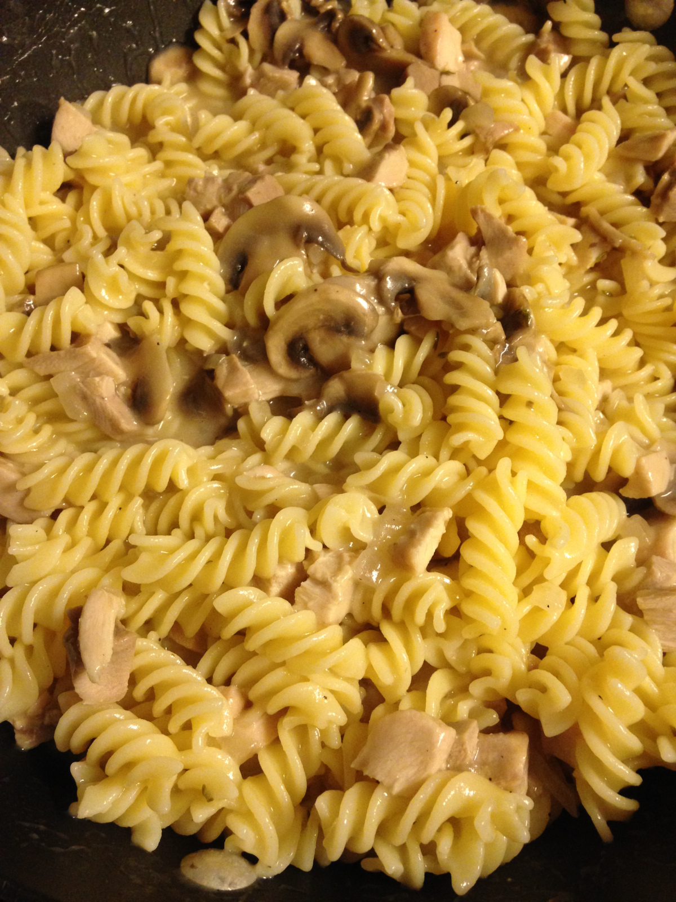

Fusilli – Corkscrew pasta, thick at core, varying length

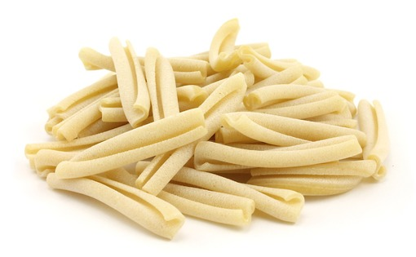

Gemelli – Twin noodles can also be twisted

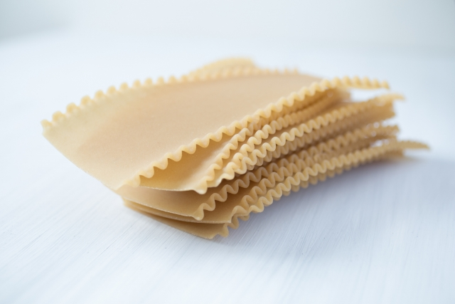

Lasagna – Thick flat noodle 3”x13”, also found in sheets

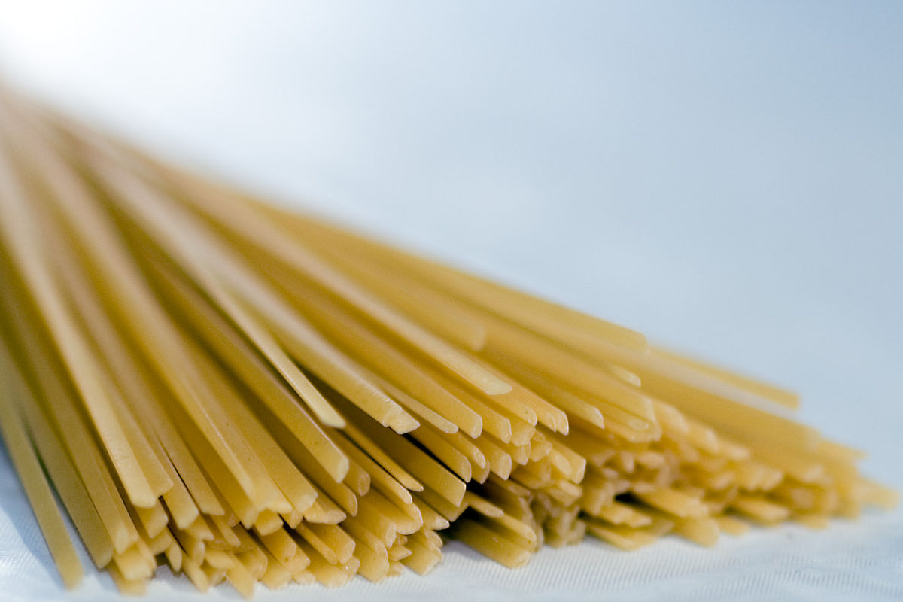

Linguine – Long flat ribbons, similar to fettucini but only 1/8” wide

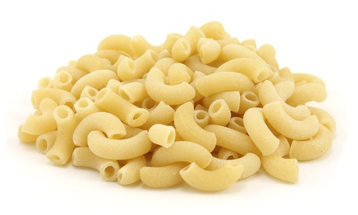

Macaroni – Small short bent tubes of pasta, regular and extra large

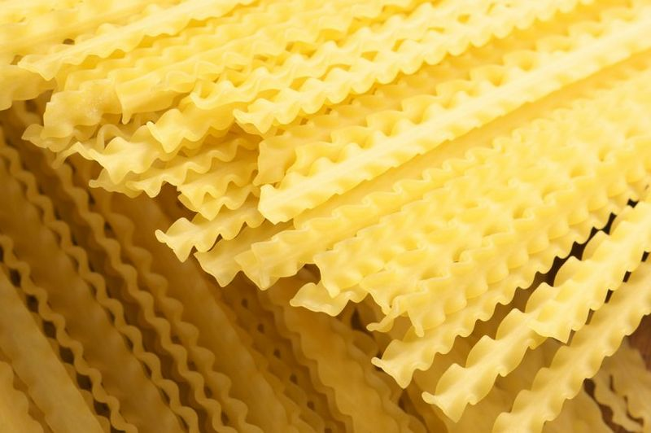

Mafalde – Skinny version of a fettuccine noodle, ruffled edges

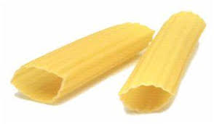

Manicotti - Large ridged tubes used for filling with meat, vegetables or
cheese

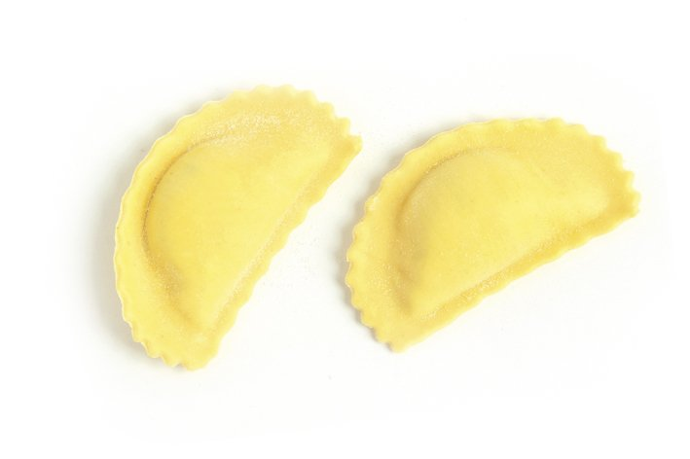

Mezzelune – Half moon pie shape in appearance, for filling Handmade

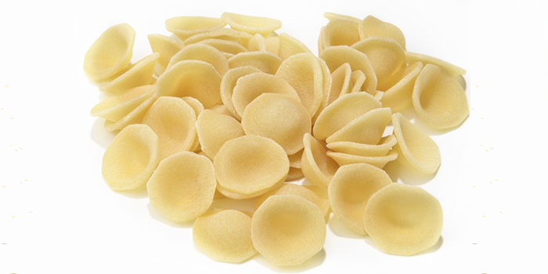

Orecciette – Round dome shaped like a hat pasta

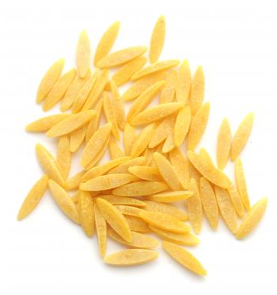

Orzo – Rice shaped pasta, except little larger

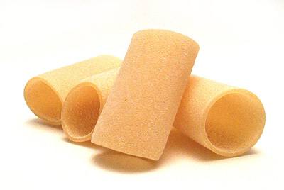

Paccheri – Large tube shaped pasta, thin walled
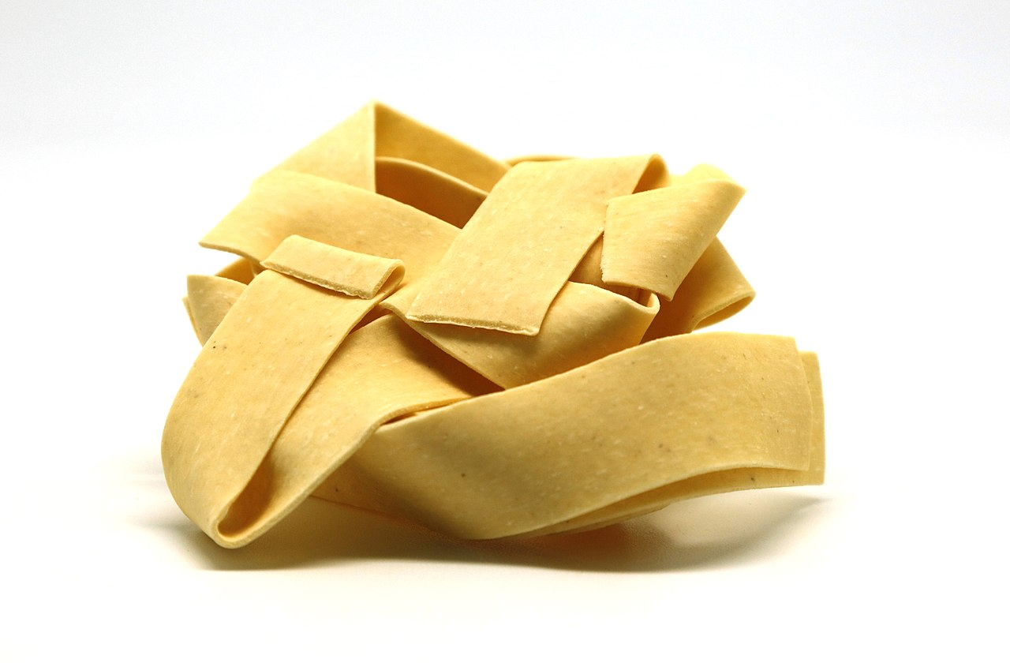

Pappardaelle – Very thick flat noodles

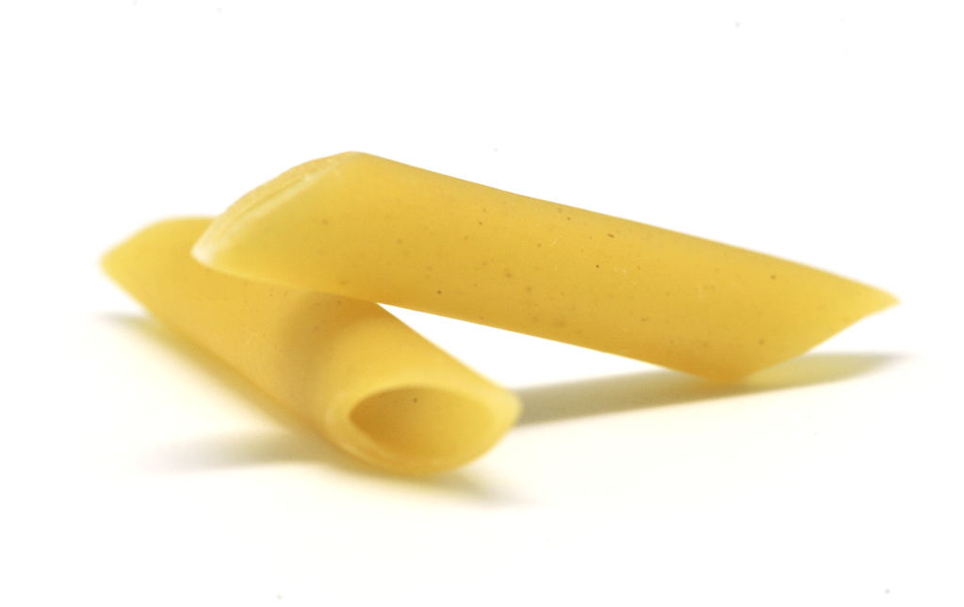

Penne – Medium length tube past, diagonally cut both ends, ridges

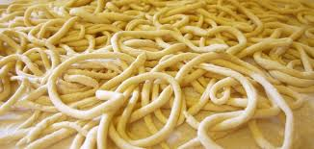

Picci – Very thick, hand roilled with a spaghetti appearance

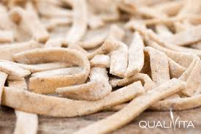

Pizzoccheri – Flat ribbon pasta made from buckwheat flour

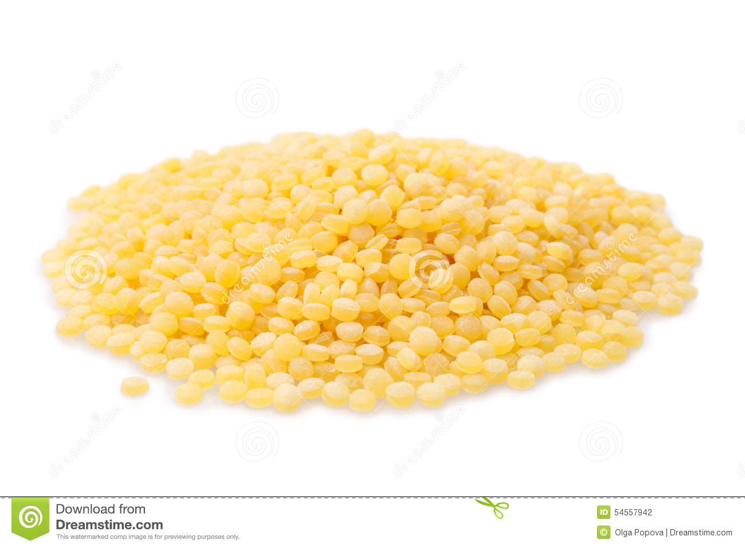

Ptitim – Grain shaped pasta, couscous in the U.S.

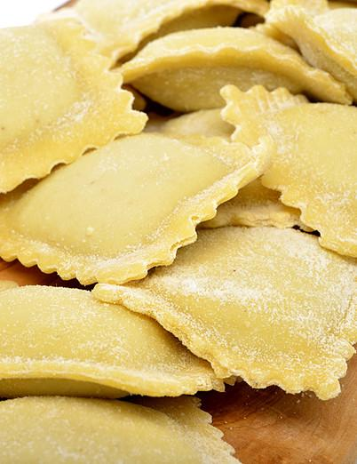

Ravioli – Square or round, covered in sauce, handmade

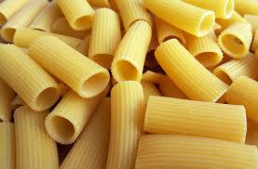

Rigatoni – 1 ½“ in length slightly curved tube ½“ diameter

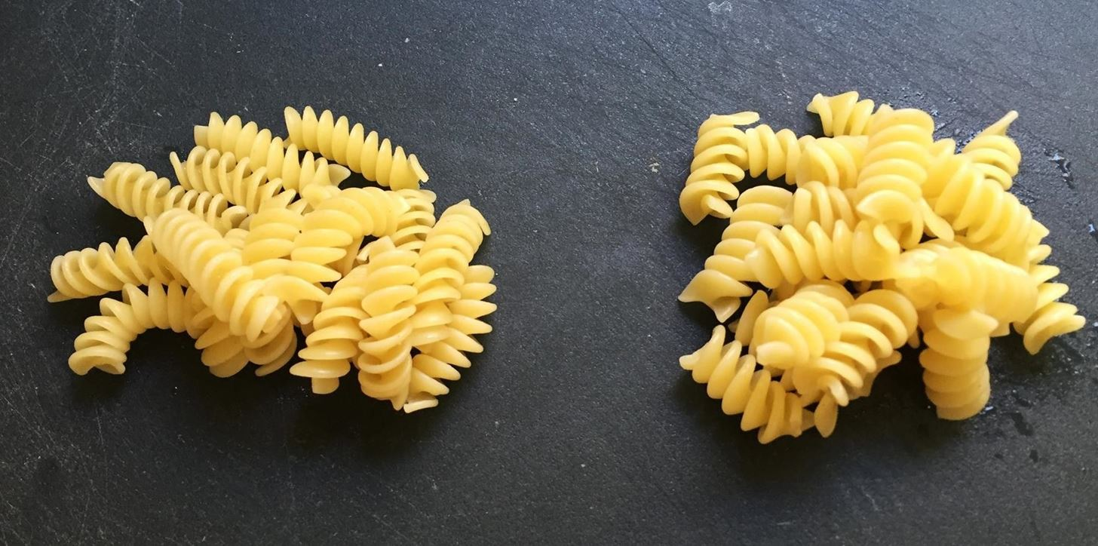

Rotini - Tighter, smaller corkscrew shaped pasta than rotelle

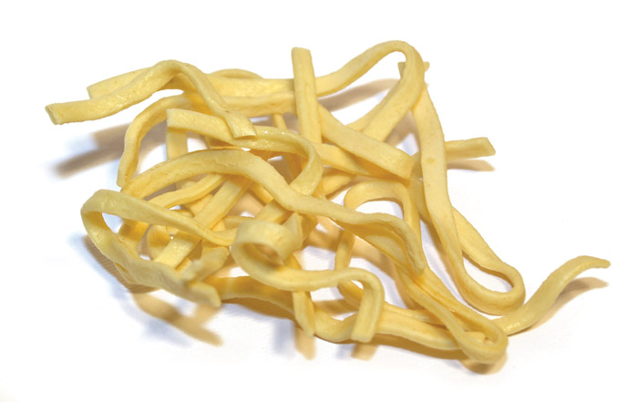

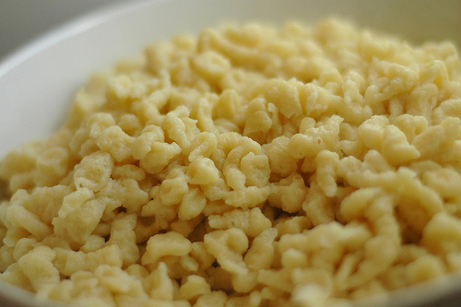
Scialatelli – Thick looking fettuccine

Spatzle – Normally round but shape can vary

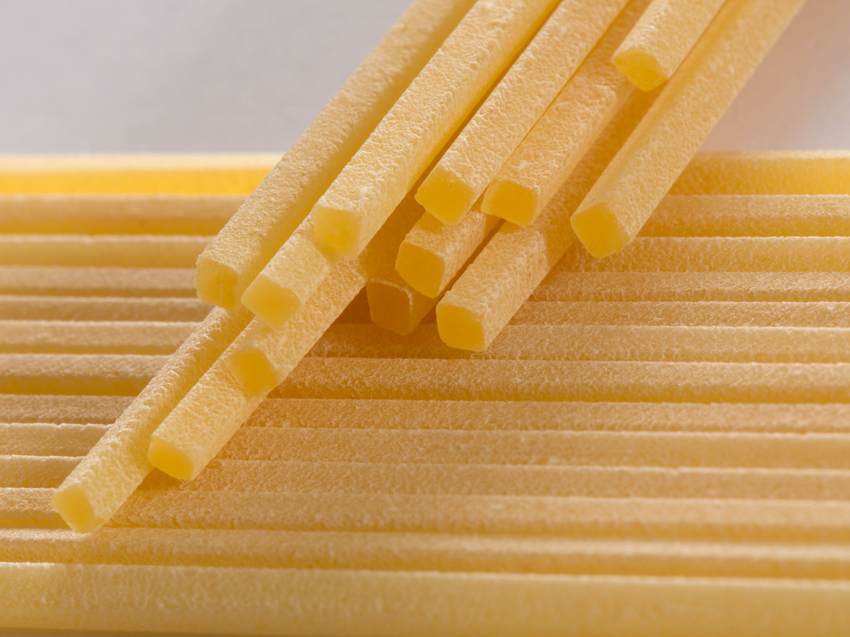

Spaghetti alla Chitara – basically a square shaped spaghetti

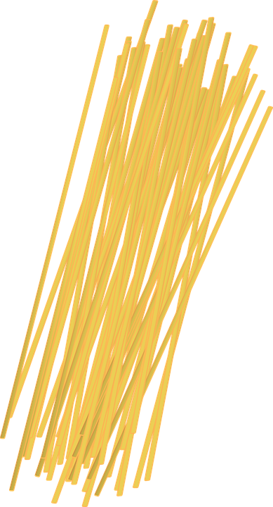

Spaghetti – Round, long strands 1/16“ in diameter

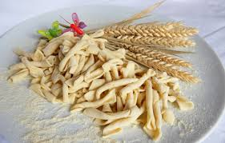

Strozzapreti – 1 1/8” pasta resembling green beans in shape

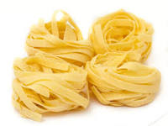

Taglierini – Narrower version of tagliere at 1/8” wide

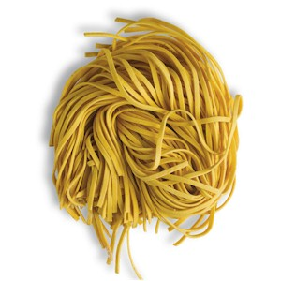

Tagliatele – Similar to fettuccine only ¼ “ wide

Taglierini – Narrower version of tagliatele 1/8” wide

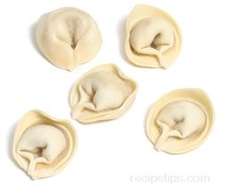

Tortellini – Filled pasta, folded into a circle and tucked like a flower

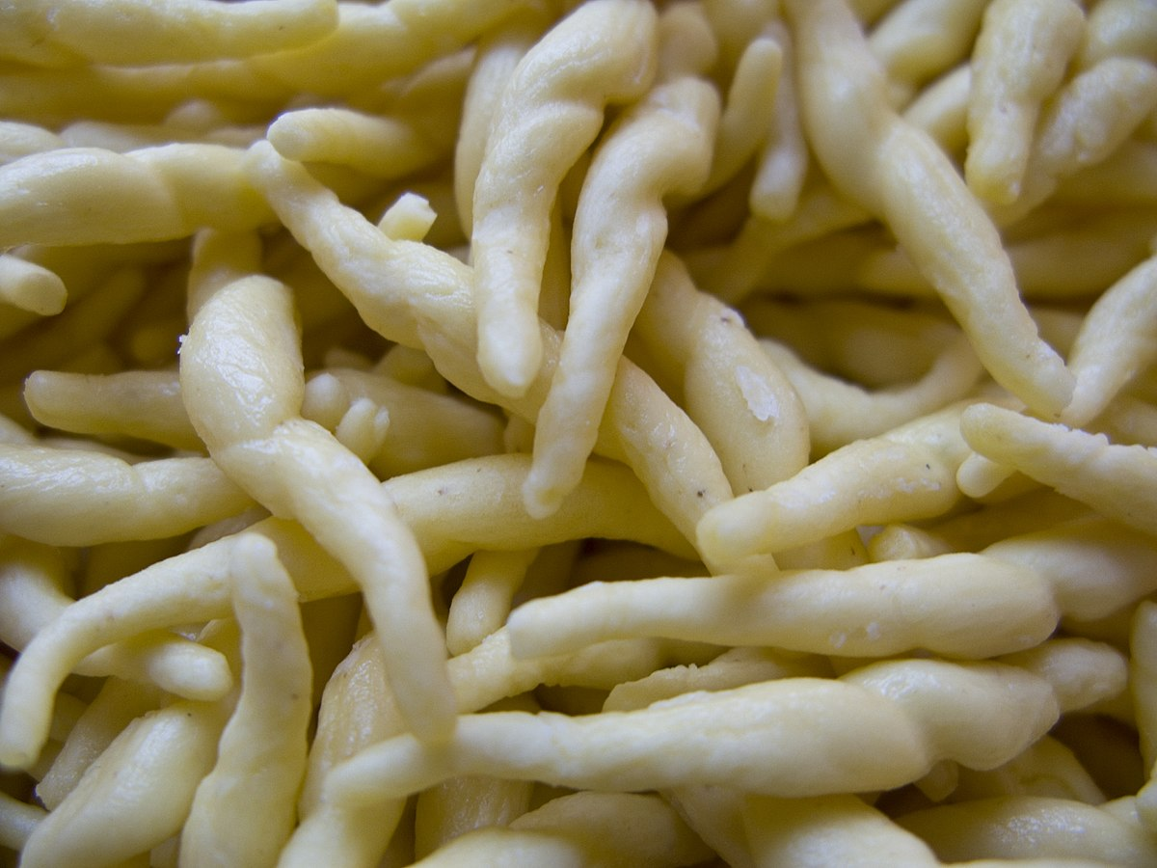

Trofie – Thin twisted pasta resembling a unicorn horn

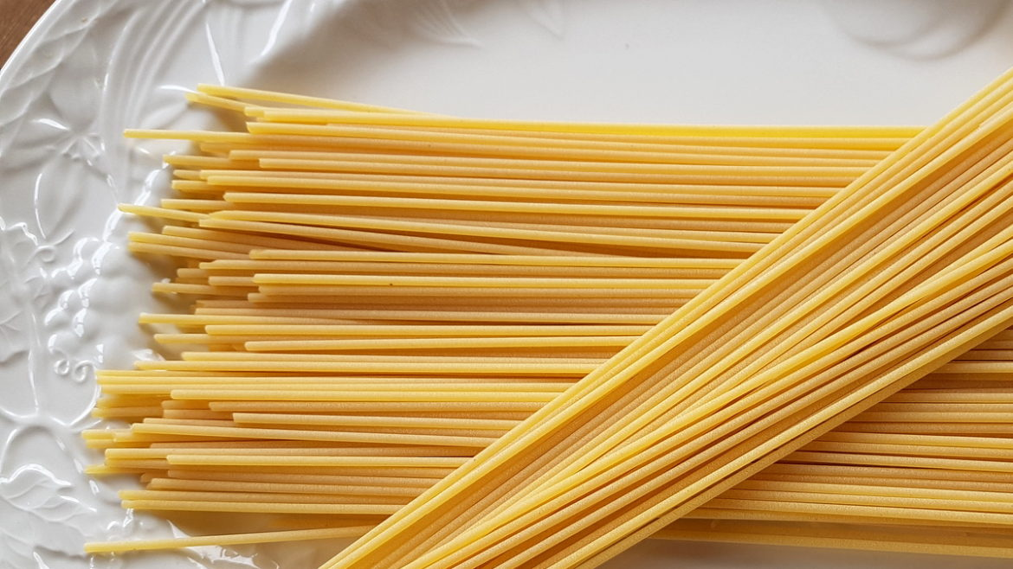

Vermicelli – Very thin noodle resembling spaghetti, rice flour,
angel hair pasta

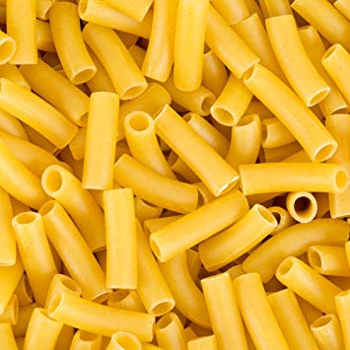

Ziti – Small version of penne, smaller than rigatoni

When cooking, follow the directions on the pasta and when making, follow exactly the ripe with no changes at least the first time around. Making pasts is actually quite simple but it all depends on you, how confident you are, how you are doing on your culinary shills and the most important factor, how hungry are you? You can purchase most pasta at your local grocery store but for a filled pasta, you will have to make the dough, filling and stuff it yourself. It is not hard but is time consuming.

